College, Career & Military Readiness

Teacher Name:
Career Cluster:
Certificate(s):
Campus:

2020-2021
Table of Contents

- TEA CCMR Page(s)

- Objectives/Test Components and Goals

- Benchmark Samples

- Calendar (Benchmark, Review, and Exam Dates)

- CCMR Student Tracking (Link Here)

- Employment Success Stories

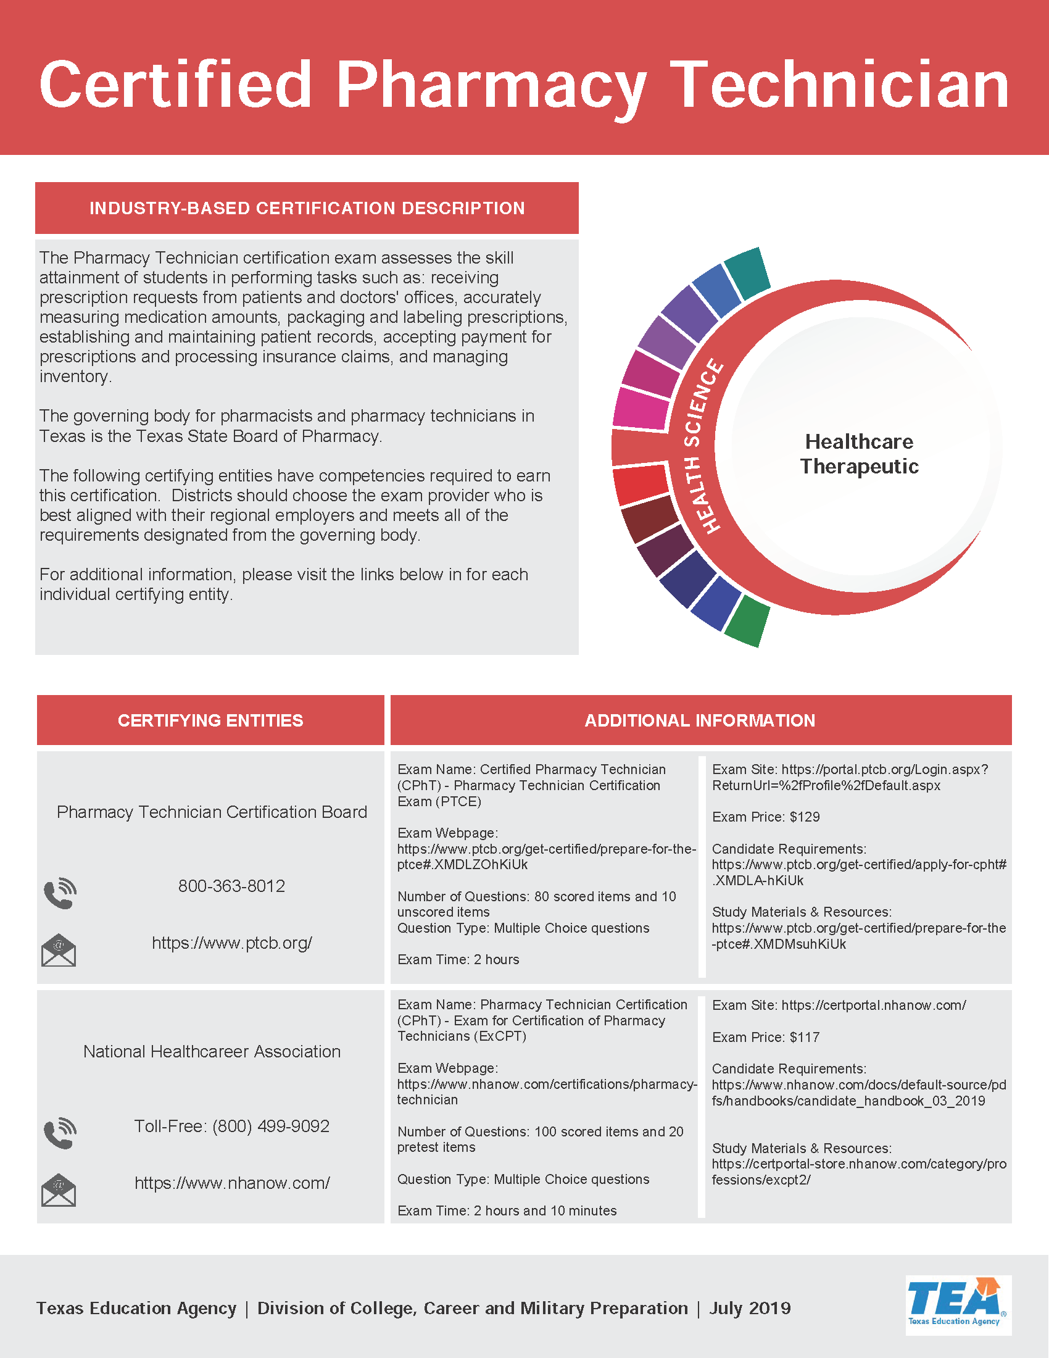

Test Components

- HIPAA

- Ethics
- Conversions
- Medical Math

- Medical Terminology

- Safety

- Communication

SMART Goals: Specific, Measurable, Attainable, Relevant and Timely

Goal 1:
Last year’s pass rate was 90%. We would like to increase our pass percentage to 95% this testing year.

Goal 2:
Student performance was weakest in Medical Math. The average score in medical math component was 70%. We would like to increase medical math performance to 80% proficiency.

Goal 3:
The second test area students struggled with was Medical Terminology. The average score in Medical Terminology was 75%. We would like to increase medical terminology performance to 85% proficiency.

Calendar Events

Review-October 20, 2019

Benchmark-October 31, 2019

Review –December 18, 2019

Benchmark-December 19, 2019

Review- February 12, 2020

Benchmark- February 13, 2020

Review- April 1, 2020

Exam- April 2, 2020

Review-April 22, 2020

Re-Test-April 23, 2020

Employment Success Stories

(Examples)

- (Student Name)– Class of 2020– Registered PharmD at Walmart 10-100 at Boca Chica Boulevard
- (Student Name) – Class of 2020 – Registered PharmD at HEB #647 in San Antonio
- (Student Name)- Class of 2019 - Registered Certified Technician at Escobedo’s Pharmacy
- (Student Name) – Class of 2018 - Registered Certified Technician at Walgreens in San Antonio

